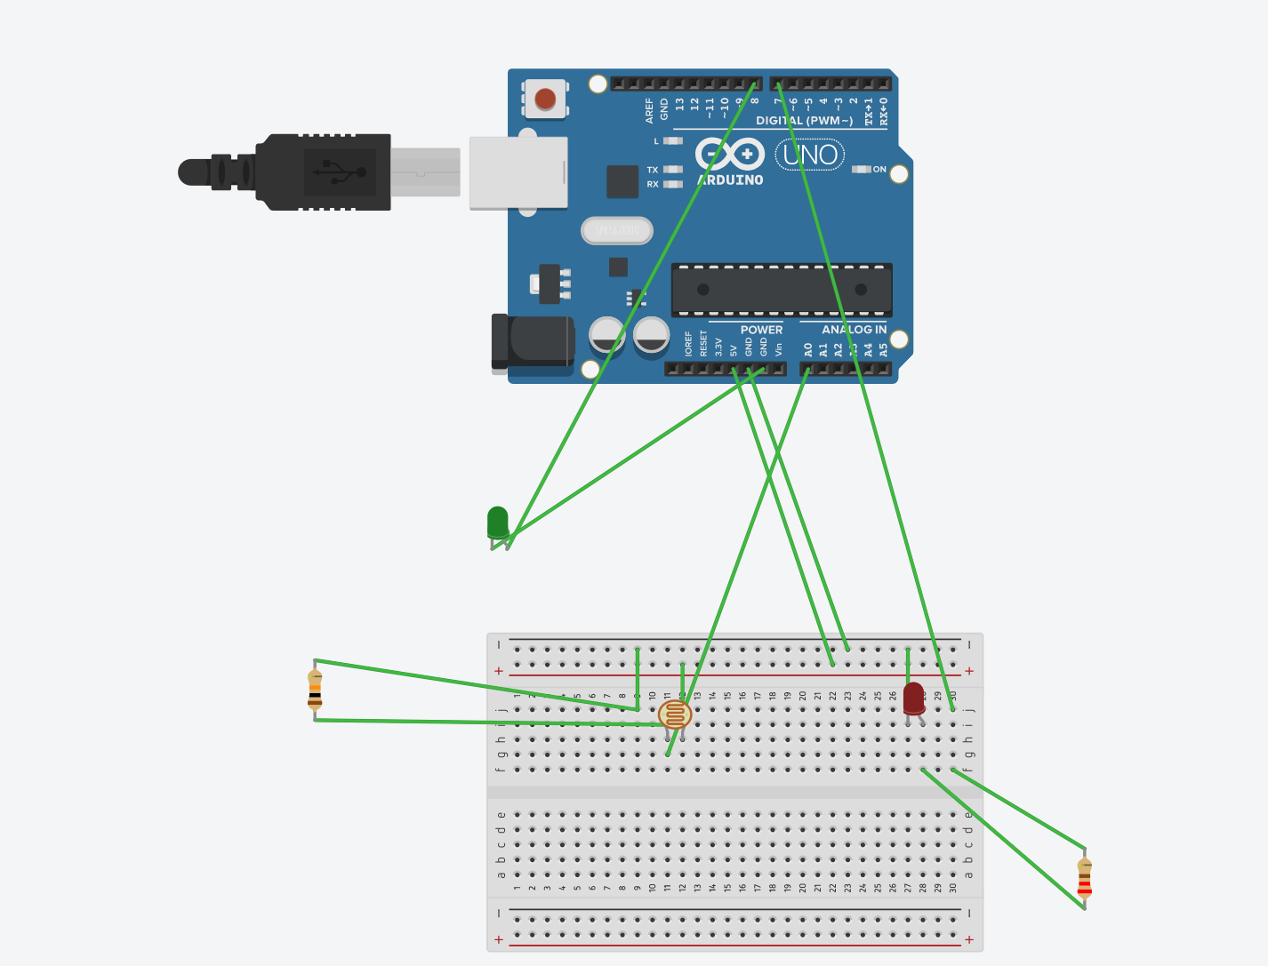

Concept used=

1. The arduino board can supply a power of 5v as digital output signals through the 14 pins present in it as digital output or input pins.
2. The GND pin of the arduino board acts as ground.
3. In the bread board present in the above circuit diagram,the two rows present at the top and bottom each are connected with each other in series and the columns present in between are connected in a 5 set of each.

Learnings and observations=

1. Making a circuit with well labeled diagram on breadboard using tinkercad.

2. How an arduino works.

3. How a ldr(photoresistor) works.

4. I have noe gained experience of how tinkercad works and now I know the concept of day/night in ldr.

Observations=

Each time we switch the photocell to night,green light turns on.

Each time we switch the photocell to day,red light turns on.

Problems and troubleshooting=

1. Missing of semi-clons in the code.
2. Not defining the lamp and lamp2.

Precautions=

1. The led should be connected properly to the circuit.
2. The code should be dry run first.
3. The resistor of 10 kohms and 221kohms must be used properly.
4. We should see if the circuit is closed.

Learning outcomes=

1. I have learned how to make circuits using arduino and bread boards and some other hardwares.
2. I have gained the skill of using ldr(photoresistor) properly and I have understood all its principles.